Distributed and Cloud Computing. Lab 1
Ivaykina Darya
Task 1. Screenshots
Client-server and commands ECHO, TIME, QUIT
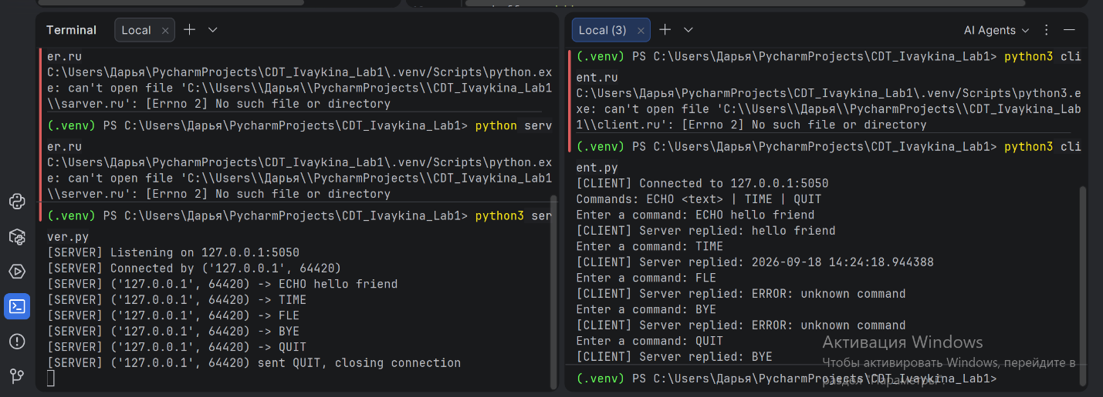

Three clients are working with one server at the same time
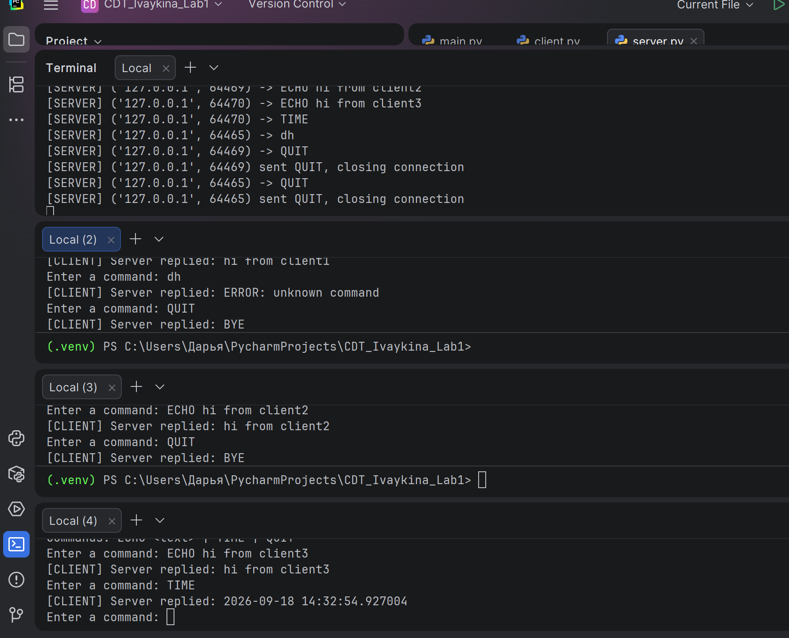
Task 2. Questions
- What is the difference between the socket used by the server to listen for connections and the socket returned by accept()?
A listening socket is created only once. It is then bound to a port and waits for incoming connections; essentially, its primary task is to accept new connections. It is through this socket that multiple other sockets can be created following a call to accept() - specifically, a new socket is bound to a specific client, and data transmission takes place via that new socket.

- Why can a single-threaded server without accept()-looping only handle one client at a time? What happens to a second client that tries to connect while the first is still being served?
If the server calls accept() only once, then after a client connects, the program's main thread is occupied solely with handling that client and cannot call accept() to accept the next connection. A second client's connection request is placed in the queue of pending connections and waits for the server to call accept() again.

- What are at least two limitations of the simple line-based protocol you implemented in Task A2, compared to a real-world protocol such as HTTP?
The main differences are the absence of structured headers—in our protocol, the message is simply a text string, which makes it not entirely secure—and the lack of response status codes; in our case, there is only an ERROR response for an invalid command.

- Why is cloud infrastructure (such as AWS) relevant to a course on distributed systems? Give one example of a component from this lab that could later be deployed on a cloud instance instead of localhost.
Because AWS helps reflect the real-world processes occurring in distributed systems. In AWS, we can test under actual conditions—such as network latency, connection unreliability, scalability, and the geographic distribution of users.

Task 3. AWS access status at the time of submission
As of the preparation of this report, access to AWS has not yet been granted. To request access, I contacted the course instructor and asked for AWS access to be arranged for the lab work. The instructor, in turn, reached out to the Dean's office regarding this matter. According to the response received, the instructor must first complete the corresponding AWS Academy course himself before access can be granted to the group. The expected date of access is the end of September 2026. Once access is granted, I will log in to the AWS Management Console and include the corresponding console screenshot in the report for the next lab

